**Freshco Hypermarket Capstone**

1. **Order level Analysis:**
2. **order distribution at slot and delivery area level.**

Top 3 delivery areas having order distribution across overall Slot - HSR Layout, ITI Layout, Harlur.

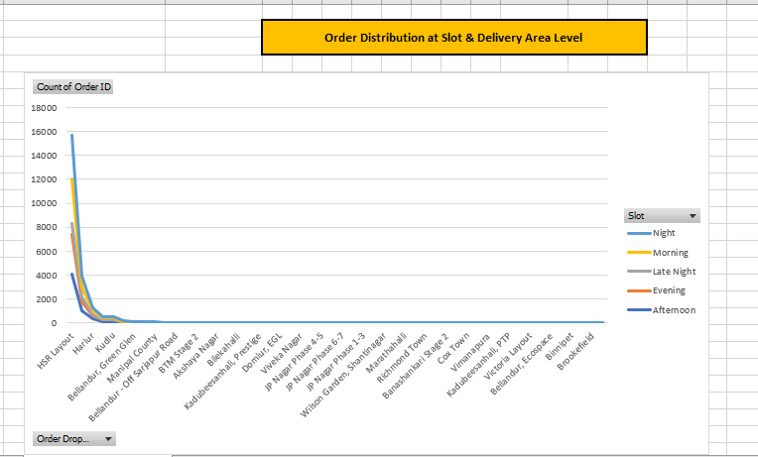

**2.    Areas having highest increase in monthly orders (from Jan to Sep) in absolute orders.**

**3.    Delivery charges as a percentage of product amount at slot and month level.**

1. Oct, Feb , Jan & March months are having maximum average delivery charges during “Late Night”
2. For Q1 – maximum delivery charges were charged during “Late Night”.

**4.    Discount as a percentage of product amount at slot and month level.**

Maximum discount was given in the August Month for all slots.

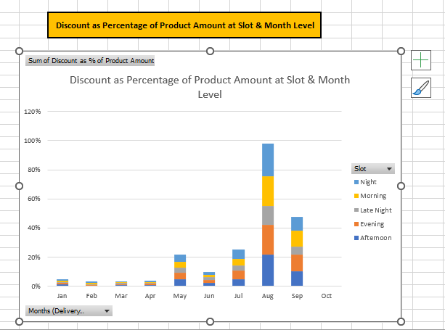

**5.    Discount as a percentage of product amount at drop area and slot level.**

Maximum discounts were given in drop areas – Harlur, Bilekahalli, Bellandur - Off Sarjapur Road, ITI Layout

**B) Completion Rate Analysis:**

**6.    Completion rate at slot vs day of the week (Sunday to Saturday) level**.

Weekend completion rate is maximum compared to weekdays completion rate.

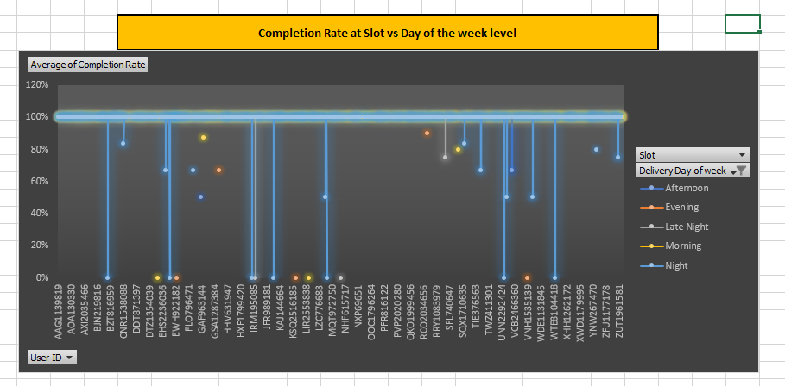

**7.    Completion rate at drop area level.**

Areas having lower average completion rate –

Bellandur, ETV (50%), Bomannahali – MicoLayout (99%) , Bommanahalli (98%) , BTM Stage 1 (97%) , Cox Town (0%) , Domlur, EGL (75%) , Indiranagar (88%) , Marathahalli (66%) , Viveka Nagar(86%), Whitefield (0%),

**8.    Completion rate at number of products ordered level.**

Maximum successful completion rate is seen for orders having product quantity in range of 1 – 10 items.

**C) Customer Level Analysis:**

**10.     Completion rate at source level.**

Highest customers were acquired from Organic (99.63%) source followed by Facebook (99.58%) and Snapchat (99.57%)

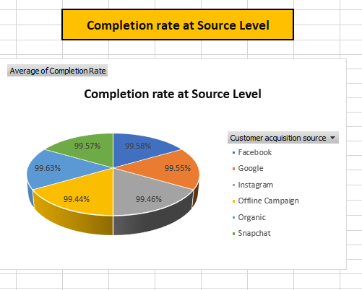

**11.   Lifetime Value (LTV)**

Top 5 customers with highest LTV -

|  |  |
| --- | --- |
| APQ2413449 | 62277 |
| ZQB198457 | 53913 |
| XXV119663 | 44898 |
| FDO1013281 | 43059 |
| LQK77449 | 42527 |

**12.    Aggregated LTV at customer acquisition source level. Refer to aggregated LTV example.**

*Google* ranks at top in terms of aggregated LTV at customer acquisition source level whereas Instagram ranks at bottom.

**13.    Aggregated LTV at acquisition month level**.

In the month of May aggregated LTV is observed maximum whereas in month of Sep it was observed minimum.

**14.    Average Revenue (Product amount after discount) per order at different customer acquisition source level.**

Top 5 orders with highest revenue across customer acquisition source level –

|  |  |  |  |  |  |  |  |
| --- | --- | --- | --- | --- | --- | --- | --- |
| **Order ID** | **Facebook** | **Google** | **Instagram** | **Offline Campaign** | **Organic** | **Snapchat** | **Grand Total** |
| 230251 |  | 6720 |  |  |  |  | 6720 |
| 334711 |  | 6700 |  |  |  |  | 6700 |
| 208921 |  |  |  |  |  | 6690 | 6690 |
| 219615 |  |  |  |  |  | 6690 | 6690 |
| 230101 |  |  |  |  |  | 5370 | 5370 |

**15.    Average Revenue (Product amount after discount) per order at acquisition month level?**

Feb, April, May month having maximum average revenue per order.

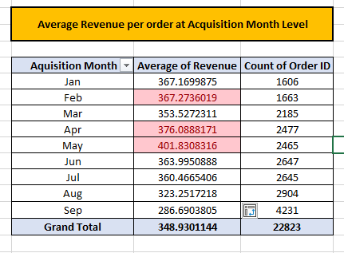

**16.    Order rating analysis –**

Maximum no of products received order rating of 5.

In Afternoon orders delivered has received rating ranging from 2 to 4 which also has received maximum average discount on orders.

Ordered with ratings 2 is having minimum average delivery charges orders delivered in “Late Night” were charged with maximum average delivery charges.

**D) Delivery Analysis:**

**17.    Average overall delivery time at month and delivery area level.**

From Jan to Sep overall average delivery time was 24 min across delivery areas level with maximum overall average delivery time in month of May (44 min).

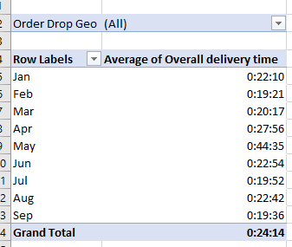

**18.    Average overall delivery time at month and weekday/weekend level.**

Highest delivery time during weekdays and weekends was observed during month of May

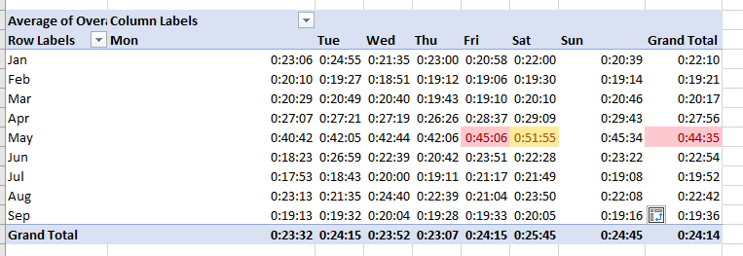

**19.    Average overall delivery time at slot level.**

Average overall delivery time was maximum during Afternoon and minimum during Late night.

